📘 COFFEE CLOUD — SERVERLESS APPLICATION BUILD & LEARNING JOURNEY
A Personal Exploration of Cloud Engineering, Architecture Thinking & Decision Making
Author: Radu Bacui
Date: 07/02/2026
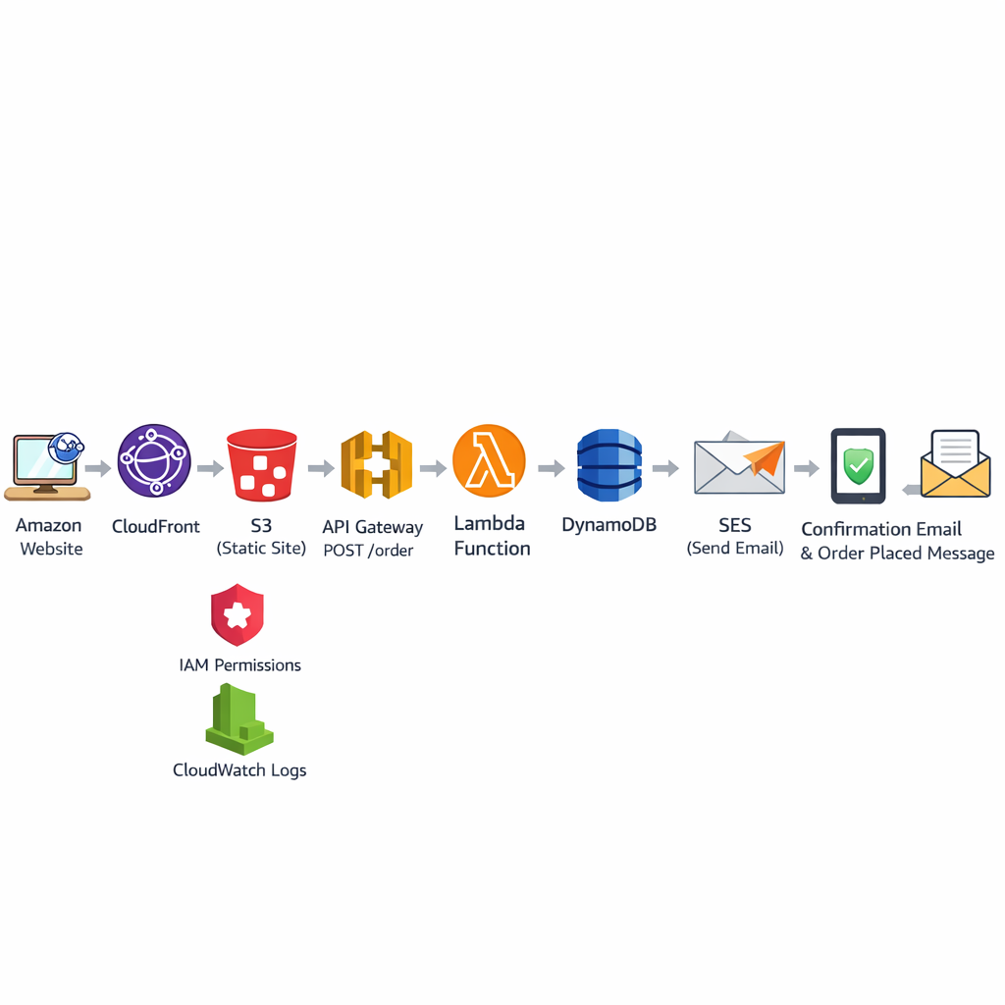

1. INTRODUCTION — WHY I BUILT THIS PROJECT
This project wasn’t simply about deploying cloud services.
It was about learning by building something meaningful, based on my own idea, where I could:
- think like a cloud architect,
- make real design decisions,
- troubleshoot real problems,
- understand how services integrate,
- and build a complete, working system from end to end.
Instead of following a pre-built template or course example, I wanted to:
✔ Invent a project idea myself
✔ Design the architecture myself
✔ Solve problems myself
✔ Learn deeply by doing
The idea I chose was a simple but powerful one:
A serverless coffee ordering system, where a customer can place an order on a website, and the backend processes it automatically.
This idea is small enough to build independently, but deep enough to cover:
- frontend hosting
- backend compute
- database design
- networking
- CORS
- IAM & security
- debugging
- content delivery
- email services
- API lifecycle
- and cloud architecture patterns
This documentation tells the story of how I built it, what each AWS service does, and why I chose it.

2. HIGH-LEVEL ARCHITECTURE
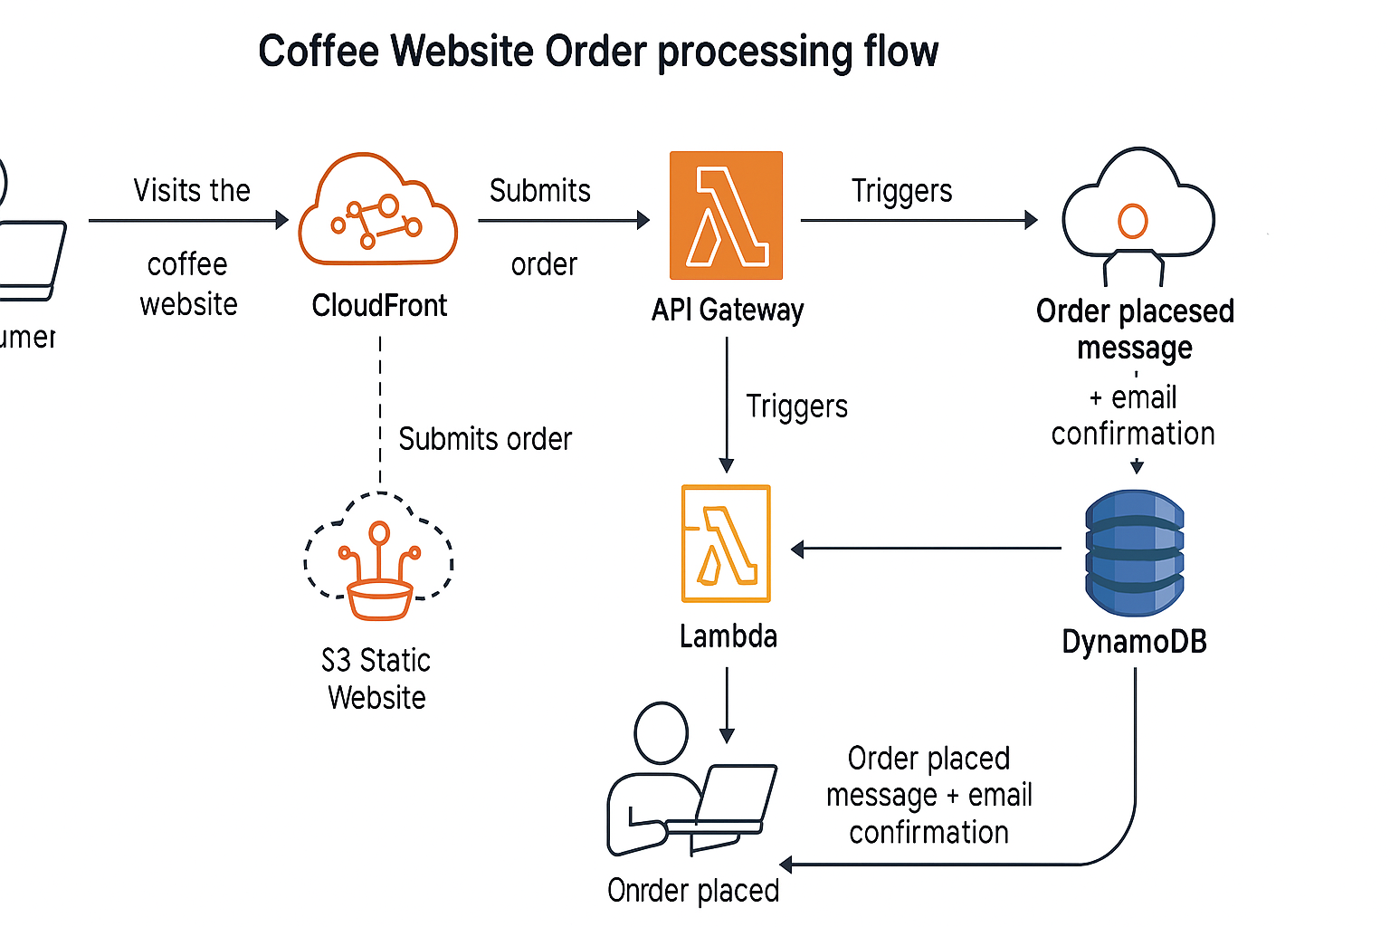

3. SERVICE-BY-SERVICE EXPLANATION & MY REASONING
This section explains, for each service:
- What the service does
- Why I chose it
- What part it plays in the system
- What I learned from it

3.1 Amazon S3 — Static Website Hosting
What S3 is
S3 is AWS’s object storage. It stores files (“objects”) like HTML pages, images, JavaScript, etc.
Why I chose it
- It’s the simplest, cheapest, and most scalable way to host static websites.
- No servers, no scaling, no maintenance.
- Perfect for a beginner but also used in real enterprises.
What role it plays in this project
S3 is where my website lives:
- index.html contains the order form.
- JavaScript inside it sends the POST request to API Gateway.
What I learned
- How static website hosting works
- How bucket permissions affect access
- Why public access must be off when using CloudFront OAC
- How S3 integrates into a secure CDN pipeline
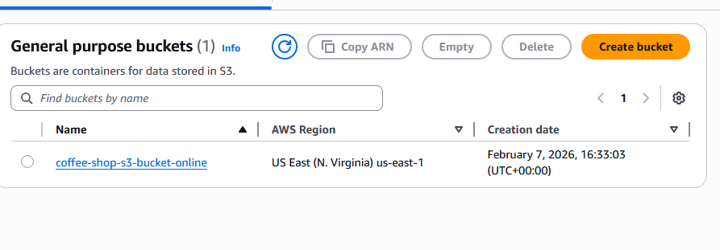

3.2 Amazon CloudFront — Global CDN & HTTPS
What CloudFront is
CloudFront is AWS’s Content Delivery Network (CDN).
It delivers content fast, globally, with HTTPS, caching, and DDoS protection.
Why I chose it
- I wanted a professional-grade website, not just an S3 URL.
- I wanted HTTPS without manually configuring certificates.
- I wanted caching and performance.
Role in the architecture
CloudFront sits in front of S3.
It handles:
- HTTPS
- Caching
- Global distribution
- Security
- OAC-based restricted access to the S3 bucket
What I learned
- How CloudFront talks to S3 via OAC
- Why bucket policies must reference the exact distribution ID
- How invalidations purge old cached files
- How CloudFront affects CORS
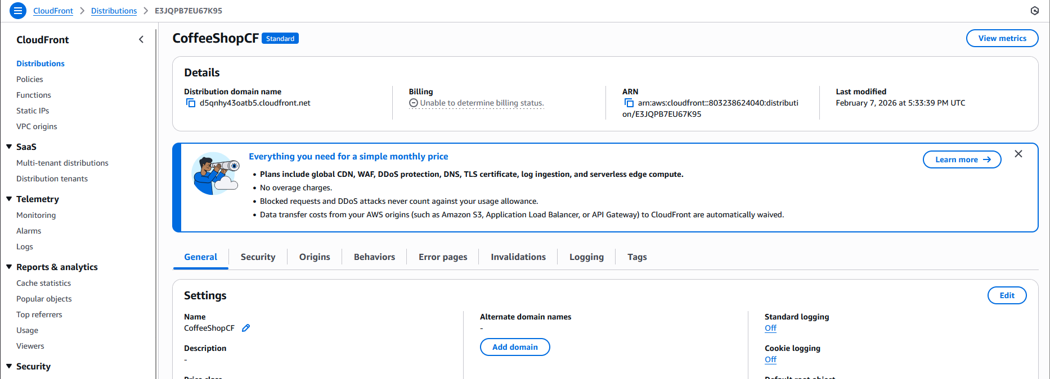

3.3 DynamoDB — NoSQL Order Storage
What DynamoDB is
DynamoDB is AWS’s fully-managed NoSQL database.
Why I chose it
- No SQL schema to manage
- No servers
- Easy to store simple key-value data like orders
- Millisecond latency
Role in the system
Stores every coffee order with:
- orderId (UUID)
- name
- email
- coffee type
- timestamp
- status
What I learned
- Importance of correct partition key naming
- Case sensitivity in NoSQL (“orderId” ≠ “orderID”)
- How Lambda integrates with DynamoDB
- How PutItem works at the raw API level
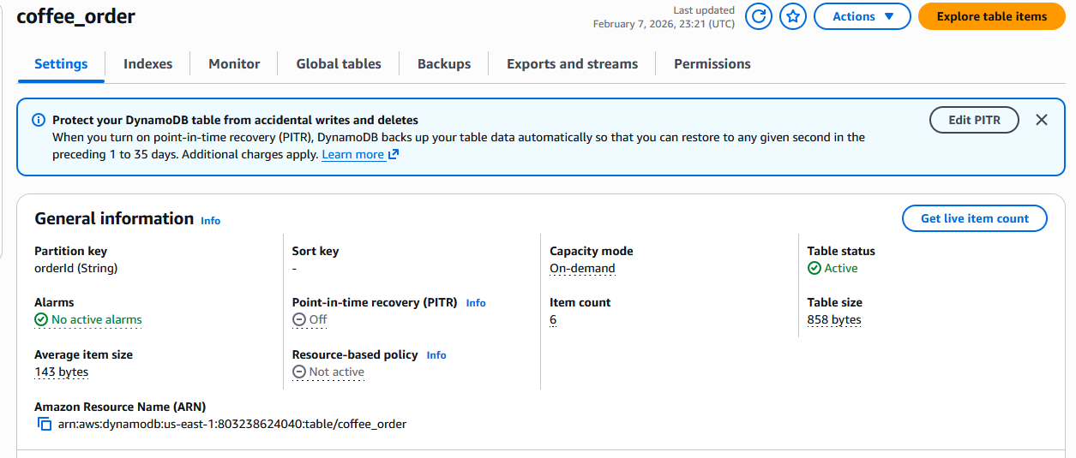

3.4 AWS Lambda — The Backend Brain
What Lambda is
A serverless compute service that runs your code automatically when triggered.
Why I chose it
- No servers needed
- Only pay per execution
- Perfect for event-driven workloads
- Great for learning Python with AWS services
Role in the system
Lambda:
- Parses the order request
- Validates it
- Writes to DynamoDB
- Sends email via SES
- Returns a structured response
What I learned
- How events work in Lambda
- How CORS needs to be returned manually
- How to debug using CloudWatch
- How IAM roles give Lambda database and email privileges
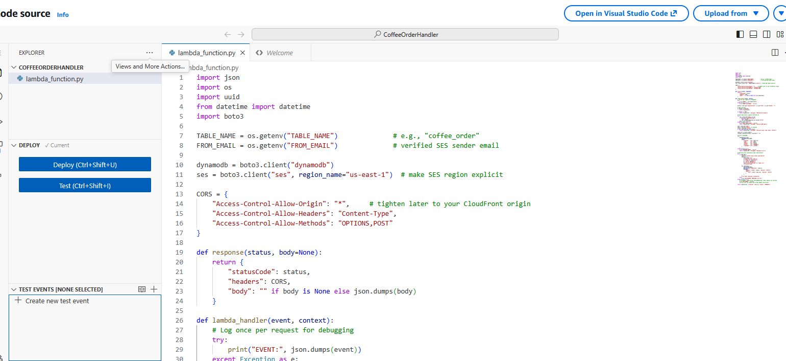

3.5 API Gateway — The Public Entry Point
What API Gateway is
A fully-managed API service that exposes REST/HTTP endpoints to the world.
Why I chose it
- Automatically connects to Lambda
- Handles CORS
- Secure by default
- Scales automatically
- Perfect for a backend API
Role in the project
Receives the POST request from the website:
POST /order
…and sends it to the Lambda function.
What I learned
- Difference between REST API and HTTP API
- How routes and integrations work
- How to structure CORS properly
- How API Gateway returns errors when Lambda fails
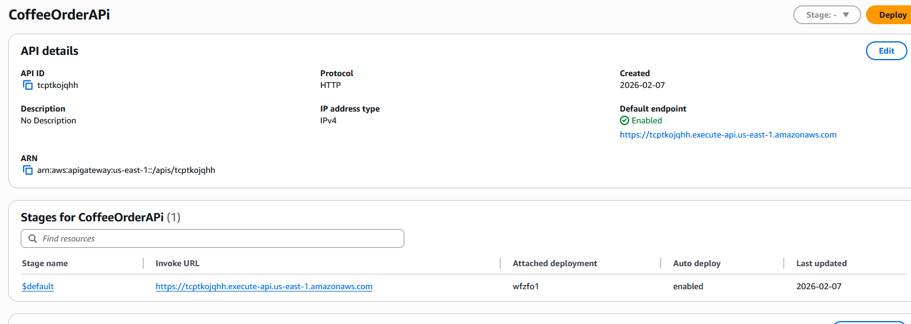

3.6 Amazon SES — Email Sending
What SES is
Amazon Simple Email Service — a transactional email system.
Why I chose it
I wanted customers to receive confirmation emails.
SES is the standard tool for that.
Role in the system
After storing the order, Lambda calls SES:
- Sends a plain-text confirmation email
- Sandbox requires verifying recipients
What I learned
- How SES sandbox mode restricts sending
- The difference between domain verification & email verification
- Why verification is required
- How to properly handle SES errors in Lambda
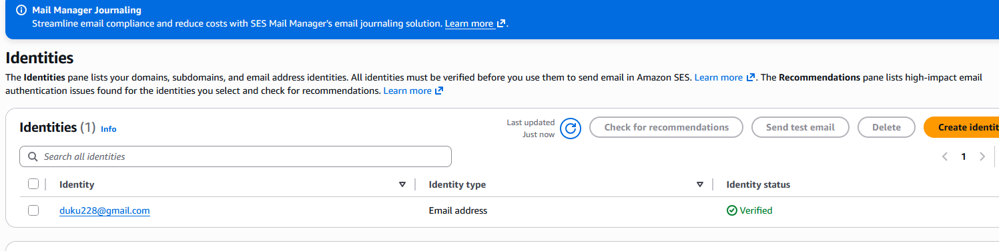

4. MY LEARNING JOURNEY (THE TROUBLESHOOTING STORY)
This is where I learned the real cloud engineering:
By breaking things — then fixing them.
Here are the major problems I faced and what I learned.

4.1 DynamoDB Key Mismatch
Problem:
Lambda wrote orderId but the table used orderID.
Lesson:
DynamoDB is case sensitive.
A small typo breaks the entire backend.

4.2 API 500 Errors
Problem:
Lambda threw exceptions, causing API Gateway to return 500.
Lesson:
Always check CloudWatch logs.
Lambda errors become API errors.

4.3 Network Error / CORS Problem
Problem:
Frontend couldn’t call API Gateway.
Lesson:
CORS is not optional — it must be carefully configured.
Browser → API → Lambda → Response must all align.

4.4 SES MessageRejected
Problem:
SES refused to send emails.
Lesson:
SES sandbox requires verifying both sender and recipient.
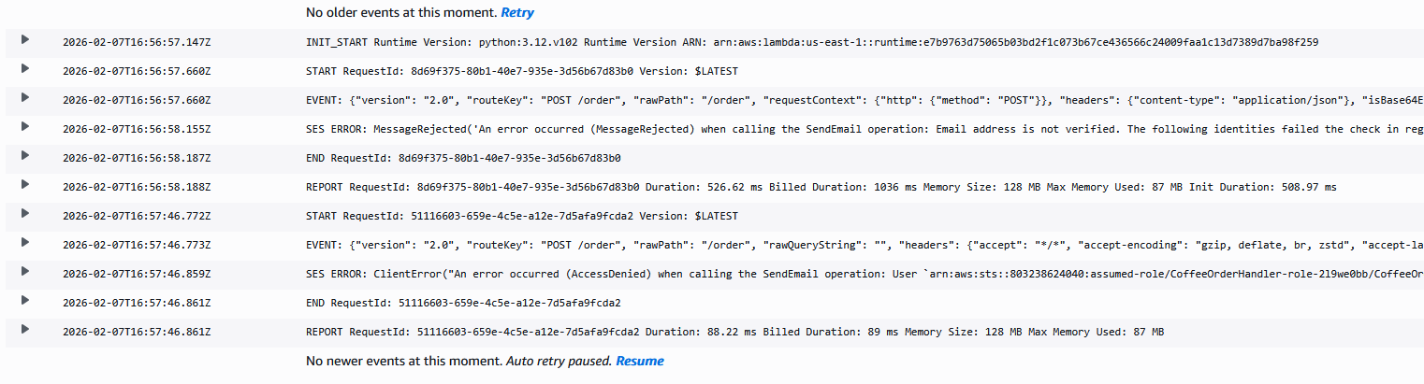
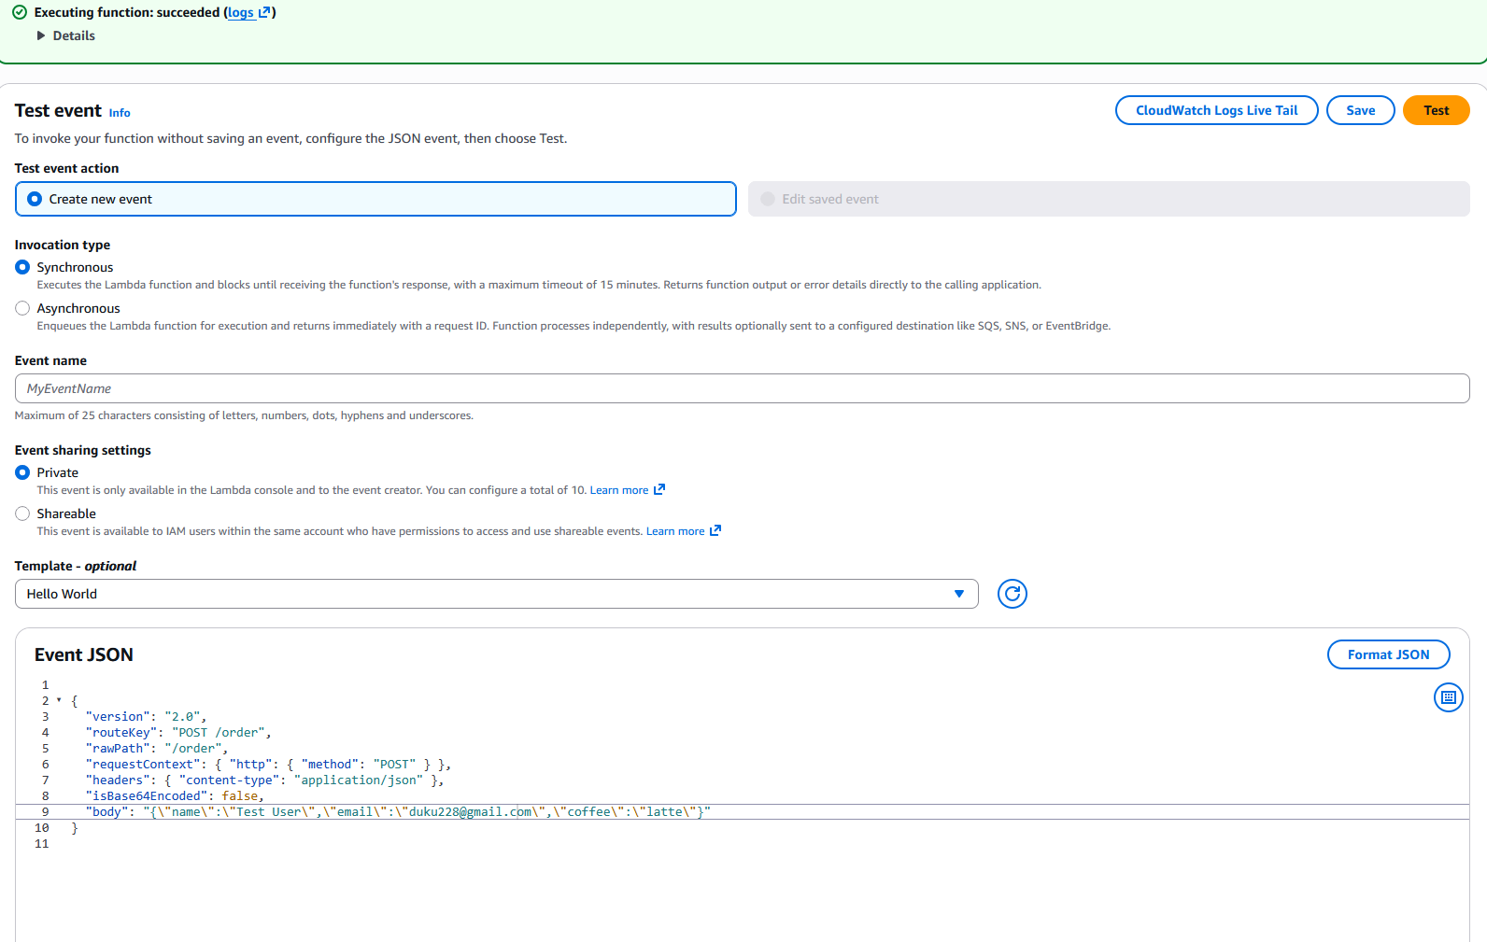

4.5 CloudFront AccessDenied
Problem:
CloudFront always returned AccessDenied.
Cause:
Bucket policy referenced the WRONG distribution ID.
Lesson:
CloudFront OAC requires a precise bucket policy.
Security is strict by design.

5. FINAL SYSTEM TEST RESULTS
- Website successfully loads from CloudFront
- API POST request succeeds with 201
- DynamoDB stores order
- SES sends email (sandbox verified)
- End-to-end system fully works
(Insert screenshots of working website & tests)

6. WHY THIS PROJECT MATTERED FOR MY LEARNING
I built this because I wanted:
- to make decisions, not follow instructions
- to understand why, not just how
- to design an architecture from scratch
- to learn AWS by actually building something
- to gain confidence troubleshooting real issues
- to see how services interact in real systems
- to deepen my cloud engineering mindset
This project required me to think like a cloud architect:
- How do frontend and backend communicate?
- How do we store data?
- How do we secure it?
- How do we deliver it globally?
- How do we handle errors?
- How do we send real notifications?
It forced me to make choices — and understand the tradeoffs.

